3.16: a) Solving Eq. (3.18) with 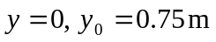 gives 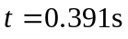.
b) Assuming a horizontal tabletop, 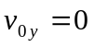, and from Eq. (3.16), 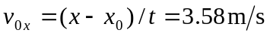.
c) On striking the floor, 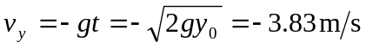, and so the ball has a velocity of magnitude 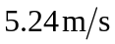, directed 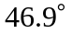 below the horizontal.

d)
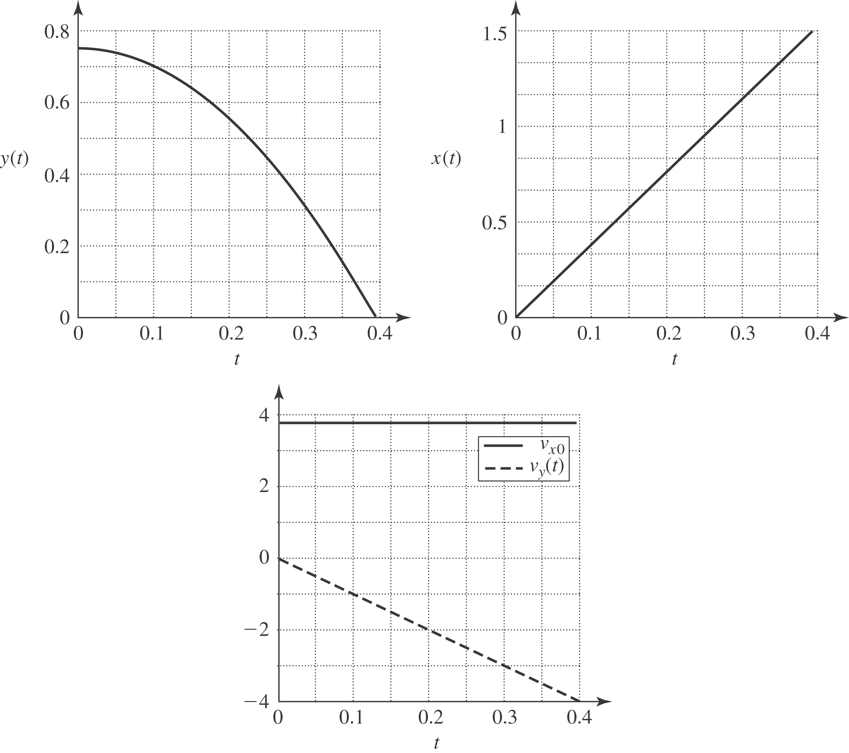

Although not asked for in the problem, this y vs. x graph shows the trajectory of the tennis ball as viewed from the side.
